**Intersect 교집합**

1. **Select * from sample71_a;**
2. **Select * from sample71_b;**
3. **Select * from sample71_a intersect**

**Select * from sample71_b;**

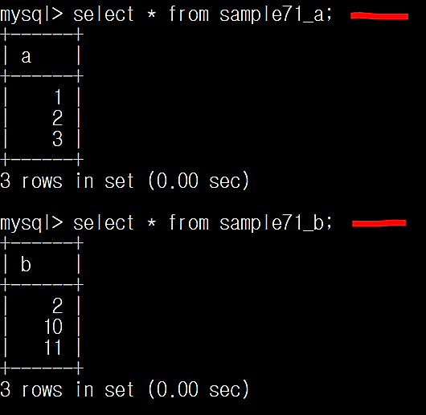

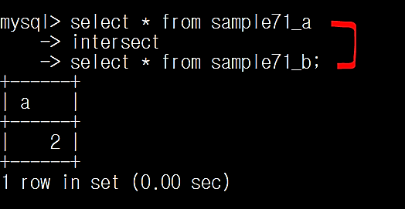

**Intersect 🡪 공통부분을 구한다 (교집합)**